PROJECT NO – 01

Diode:

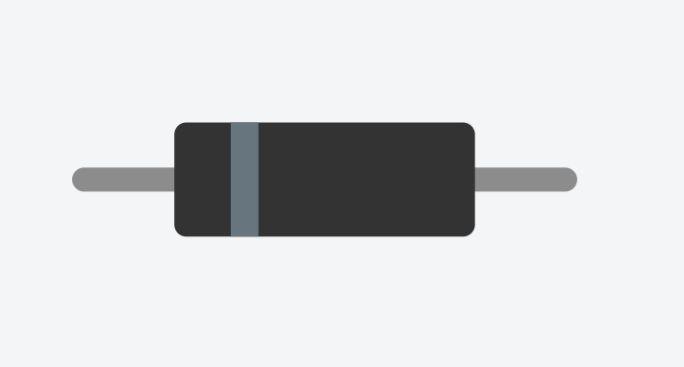

Types of diode:

1. Rectifier diodes
2. Zener diodes
3. BJT diode
4. MOSFET diodes
5. CMOS diode
6. OP-AMPS diode

(Current flowing in +ve to -ve in diode)

Half way rectifier

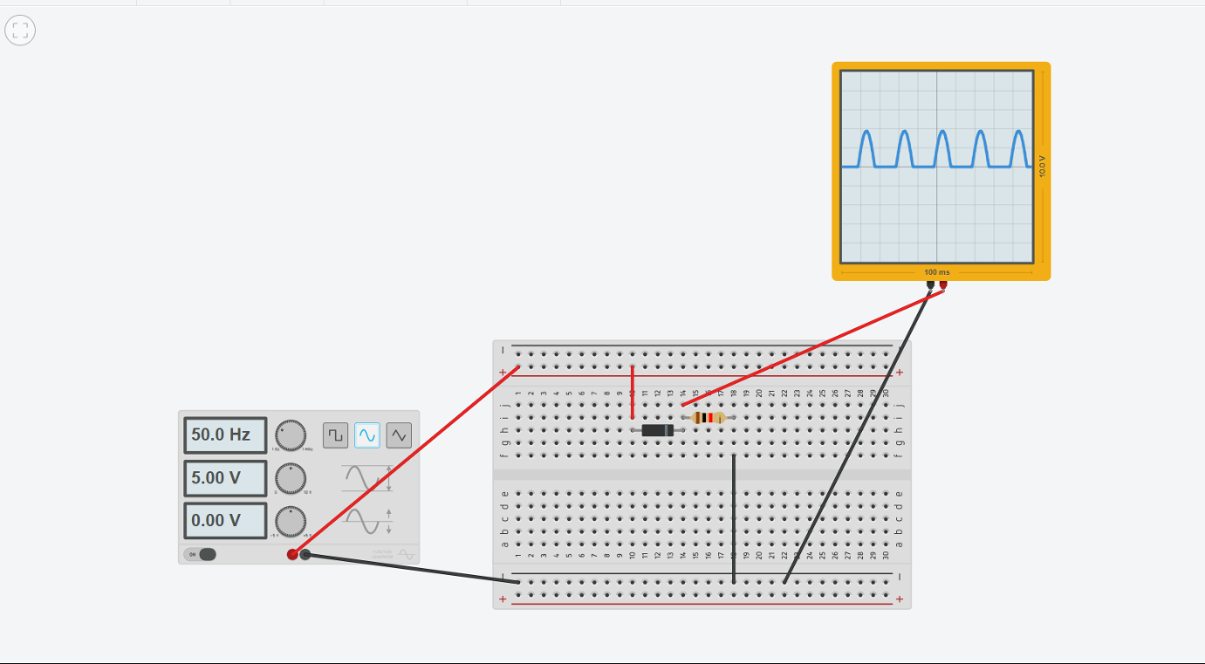

Full way rectifier

